Infosys Springboard Virtual Internship 6.0 Completion Report

Team Details
Batch Number: 2
Start date: 8th September 2025
Name(s): Pavan Kumar Pamu
Internship Duration: 8 Weeks

1. Project Title
Controlling Volume with Hand Gestures Using a Webcam

2. Project Objective
To develop a computer vision-based application that enables touch-free control of system volume using hand gestures, eliminating the need for physical contact with devices. This project aims to create an accessible technology solution suitable for smart environments, assistive applications, and advanced human-computer interaction systems.

3. Project description in detail
Approach: The project implements a sequential pipeline that converts real-time webcam footage into system volume commands. Using MediaPipe's hand landmark detection, the system tracks 21 anatomical points on the hand and calculates the Euclidean distance between the thumb and index fingertips. This distance is mapped to system volume levels (0-100%) using linear interpolation, with smoothing algorithms to ensure gradual transitions.
Technology Used: Python, OpenCV, MediaPipe, PyAutoGUI, NumPy
Real-world Impact: The application provides hands-free control ideal for hygienic environments, accessibility for users with mobility challenges, smart home integration, and immersive computing experiences where traditional input methods are impractical.

4. Timeline Overview
Week | Activities Planned | Activities Completed
Week 1 | Webcam integration setup, OpenCV configuration | Successfully implemented live webcam feed with OpenCV
Week 2 | MediaPipe Hands integration, landmark detection | Real-time hand tracking with 21-point landmark overlay
Week 3 | Distance calculation algorithm development | Euclidean distance measurement between thumb and index fingertips
Week 4 | Gesture classification based on distance thresholds | Reliable gesture recognition with dynamic thresholding
Week 5 | Volume mapping logic implementation | Linear mapping from distance to volume percentage (0-100%)
Week 6 | System volume control integration | OS-level volume control using PyAutoGUI with smoothing
Week 7 | User interface design and overlay implementation | Visual feedback with volume bar and gesture indicators
Week 8 | Final integration, testing, and optimization | Stable, responsive application with complete functionality

5a. Key Milestones
Milestone | Description | Date Achieved
Project Kickoff | Project requirements analysis and technology stack finalization | 8th September 2025
Prototype/First Draft | Basic hand detection and landmark visualization | 22nd September 2025
Mid-Term Review | Functional gesture recognition and distance measurement | 6th October 2025
Final Submission | Complete volume control system with UI feedback | 27th October 2025
Presentation | Demo of full application functionality | 7th November 2025

5b. Project execution details
The project was executed following an agile methodology with four distinct modules developed sequentially:
- Webcam Input & Hand Detection Module: Implemented using OpenCV for video capture and MediaPipe Hands for real-time 21-point hand landmark detection. This formed the foundation for all subsequent processing.
- Gesture Recognition & Distance Measurement Module: Developed algorithms to calculate the Euclidean distance between thumb tip (landmark 4) and index fingertip (landmark 8). Implemented dynamic thresholding based on hand size for robust gesture classification.
- Volume Mapping & Control Module: Created a linear mapping function using np.interp() to convert distance values to volume percentages. Integrated PyAutoGUI for system-level volume control with exponential moving average smoothing to prevent jarring transitions.
- User Interface & Feedback Module: Designed an intuitive overlay showing hand landmarks, real-time distance values, dynamic volume bar, and current volume percentage for immediate user feedback.
The entire system operates at approximately 30 FPS on standard hardware, demonstrating efficient performance suitable for real-time applications.

6. Snapshots / Screenshots
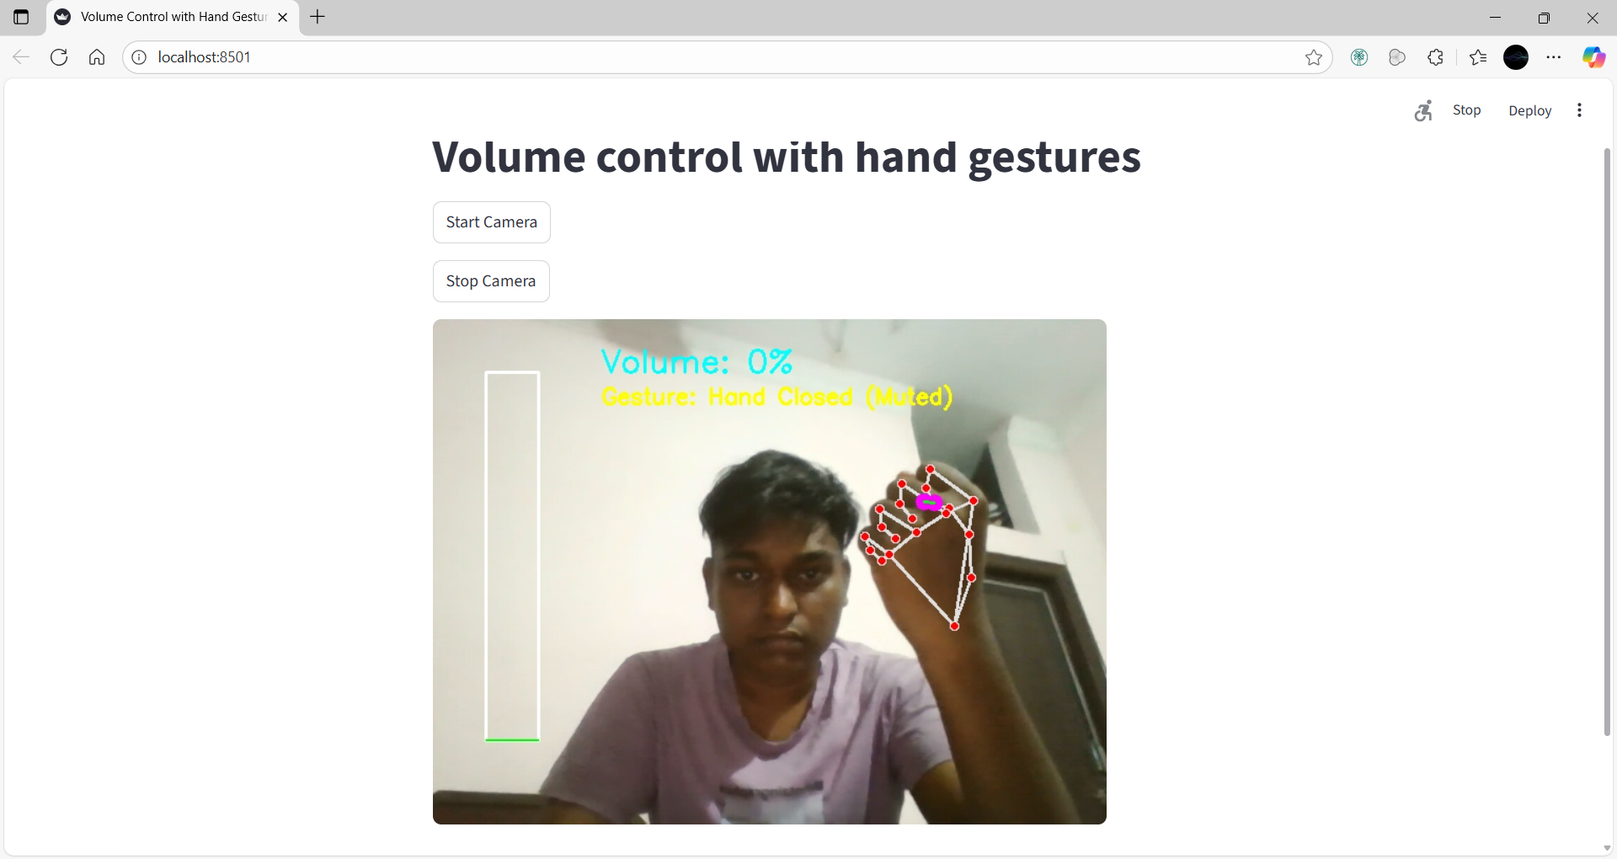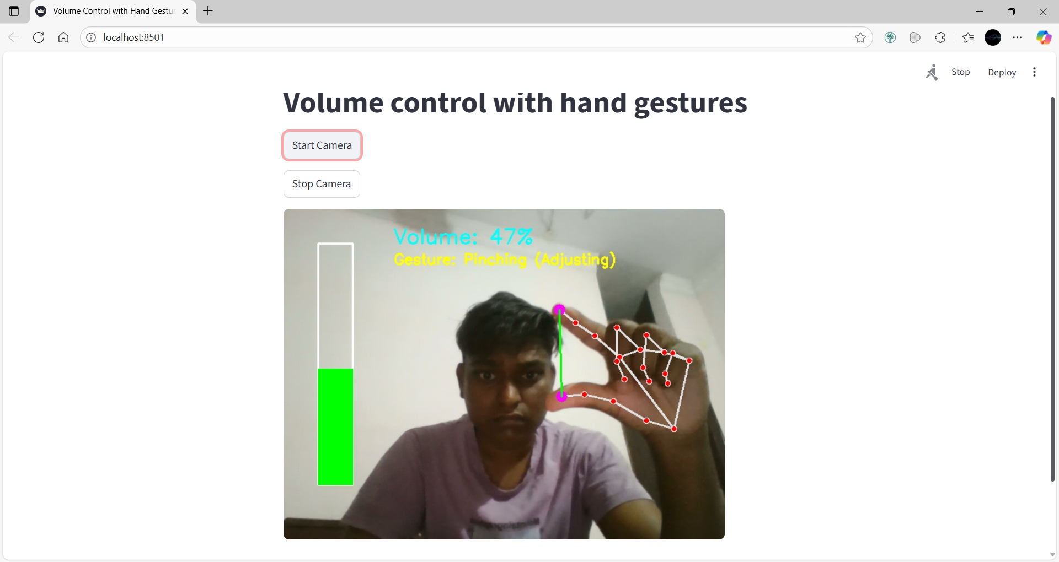
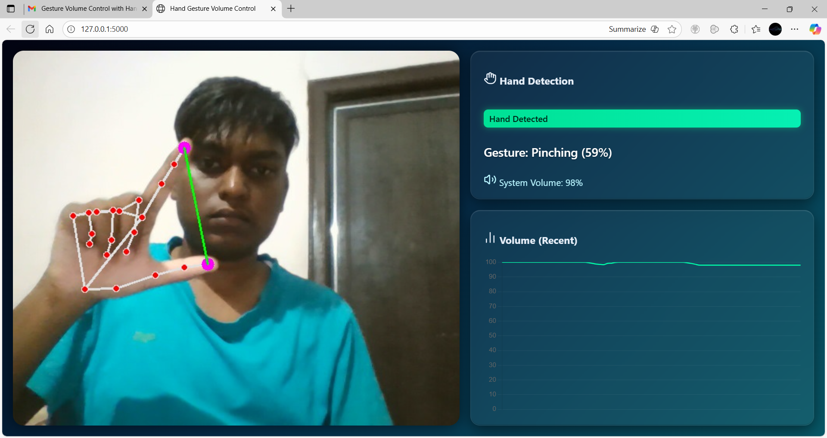

7. Challenges Faced
Technical Challenges:
- Lighting Sensitivity: Initial versions struggled with inconsistent hand detection under varying lighting conditions. Resolved by implementing hand region normalization and contrast adjustment.
- Distance Calibration: Finding optimal min-max distance thresholds for different hand sizes. Solved by implementing dynamic calibration based on hand bounding box size.
- Performance Optimization: Achieving real-time processing while maintaining accuracy. Optimized by reducing image resolution and implementing frame skipping for non-critical operations.
Operational Challenges:
- Smoothing Algorithm: Preventing volume jitter during hand movements. Implemented exponential moving average filter for stable transitions.
- Cross-platform Compatibility: Ensuring consistent behavior across different operating systems. Addressed through conditional code and platform-specific volume control methods.

8. Learnings & Skills Acquired
Technical Skills:
- Real-time computer vision programming with OpenCV
- Hand gesture recognition using MediaPipe
- System-level automation with PyAutoGUI
- Mathematical modeling for gesture-to-action mapping
- Performance optimization for real-time applications
Soft Skills:
- Project planning and milestone tracking
- Problem-solving and debugging complex systems
- Technical documentation and presentation skills
- Independent project execution and time management

9. Testimonials from team
"This project provided an excellent opportunity to bridge theoretical computer vision concepts with practical application development. The hands-on experience with real-time processing and human-computer interaction has been invaluable for my growth as a developer. Successfully creating a functional system that responds intuitively to natural hand movements was particularly rewarding."

10. Conclusion
The internship provided comprehensive exposure to computer vision application development, from concept to implementation. The successful creation of a gesture-based volume control system demonstrates the practical potential of touch-free interfaces in modern computing environments. This experience has strengthened my programming capabilities, problem-solving skills, and understanding of real-world AI applications, aligning perfectly with my career goals in AI and computer vision engineering.

11. Acknowledgements
I sincerely thank Infosys Springboard for providing this internship opportunity and the learning platform. Special gratitude to my mentor, Mr. Ram Prasad, for his valuable guidance and technical insights throughout the project duration. The comprehensive curriculum and practical approach have been instrumental in developing industry-relevant skills.

